SOUTH EAST EDUCATION DIVISION
2026 MSCE MOCK EXAMINATION
BIOLOGY PAPER II
Marking key
1.Soak been seeds for a day or two in order to allow them to start germinating (1). Take second set of bean seeds and boil them or heat them to kill them (1). Wash them with a disinfectant to sterilize them (1).
Put each group of been seeds into a sterilized vacuum flask (1). Put a thermometer into each flask and hold it in place with cotton wool at the mouth of the flask (1). Note and record the temperature of the flasks. (1) Using a clamp stand support each flask upside down and leave them for five days (1). After two days observe changes in temperature in the two flasks (1)
In the flask with germinating bean seeds, temperature will increase while in the flask with boiled seeds temperature will not change. (1)
This shows that heat is produced during respiration (1)

2.
Take six maize seedlings of the same size in which two maize (1) seedings are growing in one pot (1). Label the pots A, B and C (1)
Cut off the tips of seedlings in pot A 1-2cm from the tips (1). To the seedlings in B cut of the tips 1-2cm from the tips and replace the tips immediately. To the seedlings in C, leave them intact (1).
Leave the set ups in a safe place for the seedlings to grow for two days (1) and observe the elongation of the seedlings after the two days (1)
The expected results after two days would be that seedlings in B and C will increase in length (1) while seedlings in A will not increase in length (1)
Therefore, it can be concluded that auxins which cause growth of plants are produced at shoot tips (1)
10 marks
Q3.
a.
Class interval of bean seeds(cm) | 5-9mm | 10-14mm | 15-19mm | 20-24mm
Number of beans | 4 | 5 | 9 | 2

2 marks for all correct
1 mark for 1 or 2 correct
b
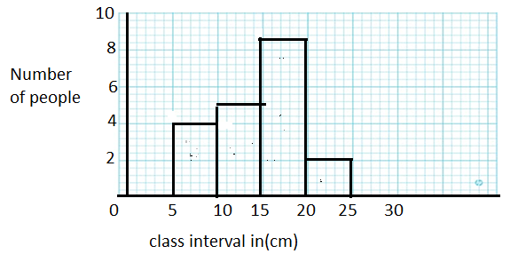
Scale = 1 mark for both X and Y ais
Labelling: 1 mark for both axes
All correct bars = 2 marks (1 mark if I bar is wrong and 3 are correct)

3c. continuous variation (1)
3d. It has a lot of intermediates
e. The variation can be caused by environment/such as mineral salts. Some beans might have been grown on soils rich in nutrients resulting in production of large seeds while others might have grown is soils not rich in nutrients resulting in small and short seeds
2 marks
The variation can also be caused by heredity/. Some varieties of the beans may have inherited genes which make the seeds to be longer than the other varieties 2 marks
The variations can also be caused by age/. Some of the beans might have been harvest while not mature and get dried causing then to be short and small while others might have been harvested while well matured making the seeds to be somehow longer 2 marks
Any one of the factors above
4. a. 60-150mm
b.
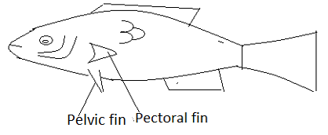
Correct diagram 1 mark
Diagram drawn to correct magnification 1 mark
Any correct two labels 2 marks
c. B is more adapted to fast moving in water (1) because it is more streamlined therefore can experience the least drag or it can easily cut through the water 2 marks

d. Two nutrients present in the specimen include proteins, lipids, vitamins and mineral salts any two ( 2 marks )

END OF PROVISIONAL MARKING KEY

